# **INTRODUCTION**

I'm working as a DevOps engineer from past 4 years , I have experience with setting up CI/CD using Jenkins from scratch.

I have also experience writing shell scripting to do the automation of the manual tasks and repetitive tasks.

Working on AWS cloud services like EC2, S3, VPC, Load balancer, Autoscaling, Cloud watch, cloud trail, Route53, KMS, etc.

I have worked on docker, I have written docker files and optimized docker image size using multistage builds and took security measures while building docker image,

I have worked on k8s I have written YMAL definition files for multiple Kubernetes objects like deployment, service, daemon set, PV, PVC, config maps, etc to deploy and manage microservices in multiple environments like DEV, STAGE, QA prod in Kubernetes clusters if there are any deployment issues troubleshooting and finding the root cause and resolving them.

I have automated infrastructure provisioning and managing in AWS public cloud using terraform scripts from scratch and

I have used Ansible to install and uninstall software on Multiple **Servers** in a single run.

# Roles & Responsibilities

• Developing Docker images to support Development, Testing Teams and their pipelines build and release managment

• Implement and maintain continuous build and deployment mechanisms.

• Managing build infrastructures environment setups and monitoring daily operations in Jenkins and troubleshooting the issues.

• Setting up Jenkins jobs and adding plugins when required for automation

• Worked on shell scripts to automate build process

• Worked on branching and merging. Creating branches for different teams and for different projects. Merging branches periodically and according to requests from dev teams.

# Daily Activities

* As soon as I login I will check for the tickets and mails if there are any critical tickets or issues that should be responded immediately, I will work on those
* After that we will be having our stand-up call and we discuss what are all the tasks that we need to perform for the day and will work on those tasks that are assigned for me
* In the evening we will have the scrum call everyday so we will discuss what are all the tasks completed and if there are any blockers and will discuss for the solution and work on those.
* We will be providing support to the developmet team if they facing any issues in pipeline, if any issues in ci cd pipeline we will be helping them to resolve those issues also we will be working on our cloud infrastructure. Or improving the current infrastructure
* Checking Health Configurations of the application

**Sprint Based Release Activity (only 1 Scrum in a 1 release 15 days once)**

**Jira** is a sprint planning tool every sprint will be planned, what task has to be done, which task will be priority, who will work on which task

Ex:-CI Cd Pipeline, Working on Cloud

We along with the teammates will be discussed once in three weeks these are the priority task each one will have separate task based on role or manager was assigning the tasks

# Challenging task you done it?

**Gearman Plugin**

When I installed Jenkins for 1st time on the server, after a month server got crashed due to some hardware issue, server didn’t come up at all. I lost the Jenkins builds were stopped from the day; we couldn’t recover Jenkins. I had to reset up Jenkins on the other server.

Now I searched for the high availability plugin, I got to know about GEARMAN PLUGIN. I installed gearman plugin in Jenkins and I configured other server details in it. If the master goes down, other server will act as a master. So Jenkins will never go down now.

**Image Pull Secrets in k8s**

When I was assigned to my current project I was assigned an POC for new microservice and the docker image was build and pushed to our private repo . I had created deployment file to deploy it to k8s stage cluster, whem I tried deployment was not happening and I was getting the image pull backoff error and then I got to know about image pull secrets and then I added the secrets to pull images and added it to my deployment file from our private repo and then the deployment got succeeded.

# About Project

This project is mainly used In order to scan RFID tags on every month basis and loads the data into the database. and whoever are associated with Every store will scan the RFID tags in the store and report on the last day of every month and gets the report.

We presently have 15 Microservices under this Centralised Application, and 5 more Microservices are in the development stage, all of these microservices are connecting to the primary ecommerce application. As part of our agile development team, we would be assisting them in building the infrastructure necessary to operate the microservices in the Kubernetes cluster and automating

code builds, application testing, and to speed up deployments. The objective of this project is to used In order to scan RFID tags on every month basis and loads the data into the database and whoever are associated with Every store will scan the RFID tags in the store and report on the last day of every month and gets the report

Java Based Application

8 in a team helping for 25 developers, 1 manager, 1 team lead and 6 Devops engineer

2 or 3 people continuously monitoring on CI CD setup for Jenkins pipeline to run smoothly

Few of them on resource provisioning and keep tracking of all resources on cloud watch on AWS

Few of them works on production env for bug issues

Working for own in-house Application. This project’s goal is to centralize the entire working process under a single platform by automating the entire process to make the application available for the end users to access under single application, Helping to create infrastructure required to run the micro services in the Kubernetes cluster, and As part of our devOps team, we would be automating code builds, application testing, and to streamline deployments . Take overall responsibility for availability of the zenius.net applications, Governance on operational processes: incident, problem, change. Ensure compliance with Daimler regulations, Define and provide whitelist of common tooling (logging, monitoring, alerting, probing). Improve customer satisfaction (end-customer, business-customer, other departments)

# Experience on each Service

AWS – 3 years

Docker – 3

Kubernetes – 3

Terraform – 3

Ansible – 3

CI CD – 3

Git Jenkins Shell Script – 6 years

# Why did you leave your last job?

The 4.5 years I spent working for the Rakuten were enjoyable. I learned a lot and made some wonderful friends during that time, but now that it's time, I feel like I'm ready for more.

And because I think I can do more, I'm looking for a new job in your organisation where I can face greater challenges and develop my skills

# Why Should we hire you?

I have 4.5 years of experience in the devOps field, and I feel that experience will make me a great fit for your team

Over the years, I have acquired relevant skills and experience, which I shall bring to your organization.

I have also worked tirelessly on my communication abilities and teamwork skills, which I will put to use in my future career, which would be in your organization if I am selected for the position.

I have given my 100% effort in my past companies, and this has enabled me to recognize my capabilities and limitations.

If I channelize them further, they will bring fruitful results to me and also to your esteemed organization.”

# Why did you decide to apply to this role?

I have been following your company’s successes for some time now and I know you have a great software development team. I was thinking that this would be the best environment for me to apply the skills

### What are your career goals?

I would like to advance in my career over the next few years through learning additional skills that increase my value as an employee. I'd work for a company like yours, that has a supportive and challenging environment and focuses on improving myself.

### What did you like about your last job?

I found the company culture to be extremely welcoming and inclusive, which I really value in an employer. I also enjoyed working with many types of people and learning how to balance their needs and personalities. I find I do best in an environment similar to that employer that challenges me and allows me to be a part of a team.

### Why do you want this job?

I read the job description that you are looking for a DevOps role with experience in aws git Jenkins Kubernetes etc which are the skills I am eagerly waiting to apply in your workplace. I believe your company culture sounds like a great fit for me and that I would be an asset to your team. I am looking to grow with a company and this seems like the perfect position for me to do so.

### How long do you want to work here?

I am looking for a long-term opportunity with a company, so I hope to work here for as long as you have a need for me and I am challenged and able to grow

### Where do you see yourself in five years?

My primary goal for the next five years is to learn additional skills and grow with an organization.

### What are your strength and weakness?

My strength is I like to learn new things and It's helping me for a better version of myself.

My strength is that I never give up, and I learn things from my weakness and failures.

My strength is that whatever work I do, I do it with full heart and interest and I consider this as my biggest strength.

weakness

Getting overconfident and overexcited when I solve some small issues and that gets my weakness because we need to work on other small and big debugs so we should not get excited so that next time when we don't know how to solve that issue then we get disappointed and that makes you us a weak learner.

### Do you have any questions for me?

*Can you tell me more about the team this role is a part of?

*What is the culture like in your organization?

*what are you expecting from me.\***Can you tell me more about the team I would be working in? like Who will I work with most closely?**

*is that I replacing someone or u r hiring me for a new role.

1) What are the day-to-day tasks?)

2) Can you describe the team and company culture?

3) Can you share examples of projects?

# CI-CD Pipeline.

CI-CD Pipeline.

• As soon as the developer finishes with their Code. He will rise the PR request. Once PR request is reviewed & approved by the approvers, the code will get merged into the GitHub, so that Jenkins’s pipeline job will get triggered automatically in such a way that we configured **webhook in GitHub**.

• In First stage will be checkout the source code from GitHub

• Next stage will be To check the quality of the source code for checking quality of the source of sourcecode we have used SonarQube. So, SonarQube will be running on the another server and we need to integrate the SonarQube with Jenkins server. For this we will install a Sonar-scanner plugin in Jenkins’s server and make the connection between the Jenkins and SonarQube for this we need Project name and access token which should be configured for authentication and run the basic quality analysis command. Developers use to check the quality of the source code by logging into SonarQube server they will check for issues like code-smell, bugs, vulnerabilities etc.

• So after this build stage will be triggered and in the Build Stage The source code will be compiled and Binary will be generated.where the code is packaged in a distributed format like jar, war, or ear. Then the builded artifacts is pushed to the artifactory using artifactory-plugin. The artifactory we are using is **Jfrog** artifactory.

• Then next stage will be docker image build stage, in this stage we write Docker file by using an required base image and other required instructions, and also we use copy command to copy the artifacts like Jar/war/ear files into the Docker file. Which are generated in the build stage. And then by running a Docker build command we will build the new docker image.

• After this the docker images is pushed to registry, we use docker push commands to push images to registry, we use Docker Registry for storing docker images.

• Then next stage will be Deployment stage we will deploy the Docker images into Kubernetes cluster like Dev, QA, Stage and Prod by witing the deployment.yml file And for the authentication of the Jenkins server and Kubernetes cluster we will install Kubernetes plugin & paste the kubeconfig file into the Jenkins server so that the authentication between Jenkins and Kubernetes cluster will happens.

• And in the last stage will be testing stage where the testing team will run the test cases. If there are any testing failure, Testing team will take care of it or if there are any pipeline integration issues, we will take care of it & fix it.

# SonarQube

Provides you the ability to analyse your code when you run a job which contains SonarQube execution within it and generates an analysis of that code in your SonarQube Server

Default Port Number - 9000

## Configure SonarQube

1. Log into Jenkins as an administrator and go to **Manage Jenkins > Global Tool Configuration**
2. Click on **Add SonarScanner for MSBuild**
3. Add an installation of the latest available version. Check **Install automatically** to have the SonarScanner for MSBuild automatically provisioned on your Jenkins executors

## Quality Gate

* Quality Gates are the set of conditions a project must meet before it should be pushed to further environments

Each Quality Gate condition is a combination of:

* measure
* period: **Value** (to date) or **New Code** (differential value over the New Code period)
* comparison operator
* warning value (optional)
* error value (optional)

For instance, a condition might be:

* measure: Blocker issue
* period: Value
* comparison operator: >
* error value: 0

# Versions of all Services

Linux -Ubuntu – 20.04

Git – 2.36

Jenkins – 2.33

Docker – 20.10.8

Kubernetes – 1.25

Ansible – 2.9.6

Tomcat – 10.0.16

Terraform – 1.1.4

Helm- 3.9.1

# Branching Strategy

* Branches can be created for multiple reasons, here we create branches for releases.
* Development team will be going on development branch, once the code is ready for the first release, we create a release1 branch from dev branch and we make a release (we do build and release it) from this release1 branch.
* Whatever the issues specific to this release will be fixed on release1 branch only. It will act as a maintenance branch for release1.
* Simultaneously development will be going on dev branch for 2nd release. Once the code is ready for 2nd release before we create a branch for 2nd release, we merge, release 1 branch to dev branch and then we create release2 branch for dev branch for 2nd release. So, whatever the issues we have seen in 1st release should not be visible in the 2nd release and so on
* BVT(build verification test) or sanity test.
* Is a basic functionality of a build which should never break.
* Sanity report.
  + ♣ Is a report related to testing and should checkbox for test.
* Release note

♣ Tag name and description and known issues.

* **Build🡪build success🡪BVT or sanity test🡪sanity report🡪release note🡪test team**
* **Build🡪build fail🡪dev team**

# Webhooks

Webhooks are basically user defined HTTP callbacks (or small code snippets linked to a web application) which are **triggered by specific events**. Whenever that trigger event occurs in the source site, the webhook sees the event, collects the data, and sends it to the URL specified by you in the form of an HTTP request.

* Go to your stack, and click on the “Settings” icon on the left navigation panel.
* Click on Webhooks.
* Click on the + New Webhook button located at the top of the page.
* In the Create Webhook page, provide the following webhook details: ...
* Click on the Save button.
* Jenkins URL need to be used

# Type of test u do in CI/CD

# **API Testing:** Checking how well an application's behind-the-scenes communication works.

# **Load Testing:** Seeing how an app performs under a heavy load of users.

# **UI Testing:** Making sure the visible part of an app looks and works right.

# **Regression Testing:** Confirming that recent changes didn't break old stuff.

# **Unit and Component Testing:** Testing small parts of the code to ensure they work correctly.

# **Functional Testing:** Checking if the app's features do what they're supposed to.

# **Non-functional Testing:** Testing things like speed, security, and usability.

# **Cross-Browser Testing:** Ensuring the app works well in different web browsers

# Jenkins pipeline scripts and difference

* 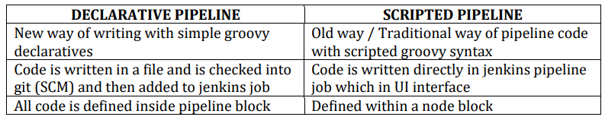

# Jenkins declarative script?

A valid Declarative pipeline must be defined with the “pipeline” sentence and include the next required sections like AGENT, STAGES, STAGE, STEPS

**AGENT**

* An agent is a directive that can run multiple builds with only one instance of Jenkins.
* This feature helps to distribute the workload to different agents and execute several projects within a single Jenkins instance.
* It instructs Jenkins to allocate an executor for the builds.
* A single agent can be specified for an entire pipeline or specific agents can be allotted to execute each stage within a pipeline. Few of the parameters used with agents are:

**Any**

Runs the pipeline/ stage on any available agent.

**None**

This parameter is applied at the root of the pipeline and it indicates that there is no global agent for the entire pipeline and each stage must specify its own agent.

**Label**

Executes the pipeline/stage on the labelled agent.

**Docker**

This parameter uses docker container as an execution environment for the pipeline or a specific stage. In the below example I’m using docker to pull an ubuntu image. This image can now be used as an execution environment to run multiple commands

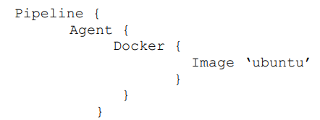

**STAGES & STAGE**

* This block contains all the work that needs to be carried out. The work is specified in the form of stages.
* There can be more than one stage within this directive. Each stage performs a specific task.

**STEPS**

* A series of steps can be defined within a stage block.
* Steps are carried out in sequence to execute a stage.
* There must be at least one step within a step’s directive.

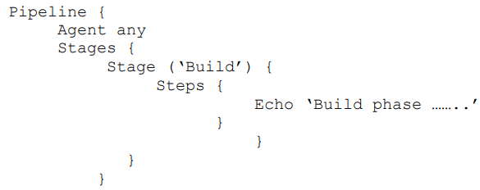

**SAMPLE DECLARATIVE PIPELINE**

**Pipeline {**

**agent any**

**stages {**

**stage (‘Build’)**

**steps {**

**echo ‘…’**

**}**

**}**

**stage (‘Test’) {**

**steps {**

**echo ‘…’**

**}**

**}**

**stage (‘Deploy’) {**

**steps {**

**echo ‘…’**

**}**

**}**

**}**

**}**

# Configure SonarQube

SonarQube will be running on a software TC to instance server and when we try to configure the SonarQube we need to integrate the SonarQube with jenkin server for that we need to create like to run in his scanning analysis we should be an Admin so then only we can run the analysis the scanning and great the sonarqube with a jenkins so first we need to create the sonarqube we need to create the project we need to generate the token so the token which will be generated it can be visualise only once so we should save that token separately and the comment the best on the source code which we are trying to scan the source code the comment we can use it so if you are just trying to uske andar use the comment that that will be provided by the son of community itself the basic comments we need to install the solar scanner plugin in the manageable games and after installing the son of scanner plug in we need to go to the configure system and we need to address we need to give the name for the configuration and we need to give the URL of the son of you and we need to provide the token so then the Sonar junction

so that the Jenkins and son are you will get authenticated each other and the next step is we need to add this solar cubes scanning in the increase brightness stage in the stage we will be calling the son of potentials with help of environmental variable will be using the which son are you be and we and give the name while which we are used in the configuration system configuration so after that will be using the comments that that the basic comment which we got from the son of you community to run the source code we can use the command as per the source code that we are using and so once the solar scanner and we can the developers used to VV also we can use the solar we need to go to the Sonar server and check scanning report analysis it will show the vernal abilities course any course you can check so that the developers used to check it manually as of now

# Prometheus

[Prometheus](https://prometheus.io/) is an open-source monitoring solution for collecting and aggregating metrics as time series data. Put more simply, each item in a Prometheus store is a metric event accompanied by the timestamp it occurred.

Prometheus stores events in real-time. These events can be anything relevant to your application, such as memory consumption, network utilization, or individual incoming requests.

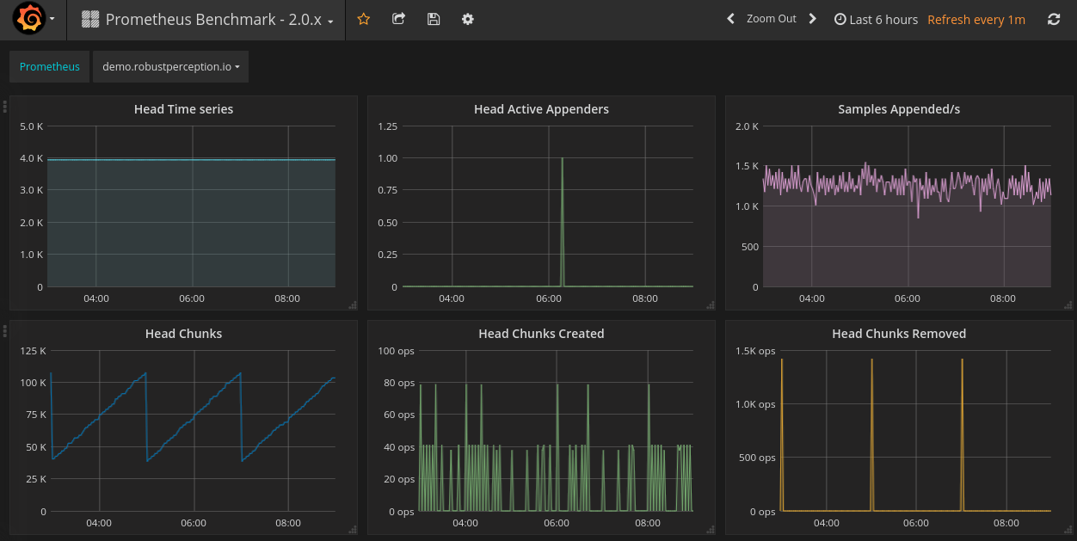

Prometheus is a monitoring tool, which you can use to monitor a variety of **infrastructure and application metrics like**

#### Service Metrics

#### Host Metrics

#### Website Uptime/Up Status

#### Cronjobs

# 1. What is your role in a team?

--> “I am equally comfortable taking the lead or allowing a coworker to delegate tasks to me. In my previous experiences, I have managed projects with teams and also worked under the direction of other team leads. My experience working with a diverse group of people with unique skills and abilities has allowed me to understand that I may require to shift and adjust my role according to the project.”

# 2. If you make a mistake, how do you fix it?

--> “When I make a mistake, I immediately communicate it and create a plan to rectify it. In my first role as a software developer, I realised that the code I wrote would lead to some bugs down the line. In this situation, I communicated my mistake and resolved it immediately.”

3. How do you resolve workplace conflicts?

--> “I believe it is essential to resolve all conflicts with coworkers as soon as possible without involving the upper management or other individuals. Conflicts become harder to resolve if they persist for long periods. However, most conflicts occur because of miscommunication, so I schedule a meeting with the relevant individuals and allow everyone to express their views. This allows us to resolve the conflict effectively.”

# 4. If your team resists your idea, what would you do?

---> “Implementing new ideas can sometimes be challenging, especially when it causes significant changes to the team's work process. To avoid challenges and reduce risks, I provide all the evidence available to support my belief that the idea would be beneficial. If my team continues to resist the idea, I typically ask them for any alternative ideas they can offer. Otherwise, I try to gather more resources to gain their support."

# 5. What motivates you at work?

--> “I am motivated by the desire to help guide all of my team members to success. For example, I remember when I was helping one of my team members complete a new task. I provided them with examples of similar tasks I completed in the past and some helpful tips. They ended up receiving praise for this task and it fulfilled me knowing I helped them accomplish success."

# 6. Why are you seeking employment in our company?

--->"I believe the best place for me to advance my career is with a stable and well-respected company. CBA is internationally known for its products and its mission, and has a history of providing its employees with a happy yet challenging work environment. I want to be part of a company where I can continue to use and expand my skill set and knowledge of this industry. Furthermore, I believe my past experiences in the industry qualify me for this position, and I'm ready to take the next step in my career."

# 7. What are your long-term career goals?

---> “I have significant experience with software development, but I would now like to take on managerial responsibilities. I want to become a leader with several teams working on different projects simultaneously. Considering the number of projects your organisation runs, I believe I can work towards that aspiration."